WHEELCHAIR TENNIS WARM UP GAMES AND DRILLS

I. WARM UP GAMES

“Sharks’
- tag game
- “fish” (players) on one side of the court/gym ( north side of bay). 1-2
“shark” (player) in the middle
- Fish trying to push to the other side of the court/gym (south side of bay).
Shark is trying to catch (tag) the fish. If fish are caught prior to reaching the destination, fish are either out of the game or they become sharks themselves
- Last fish surviving wins

“Robbers and Cops”
- Tag game
- 1 -2 participants are cops, rest are robbers
- cops trying to catch (tag) robbers
- if caught robbers got to “jail” ( stand still and have to put hands up to side)
- they can be freed from jail if other robbers push under the outstretched arms
- the game is over if all robbers are caught
- Court size: depending on # of participants court size is either full court (full gym) or half court (1/2 gym). The more participants the bigger the court.

“Pac-Man”

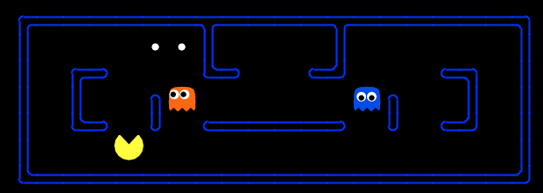

- Tag Game
- 1-2 “ghosts” – rest of participants are “pac-men”
- Everybody (!) is only allowed to move on lines of the court/gym. The net is considered a line as well as the service line through the doubles alley and middle line (view graph below)

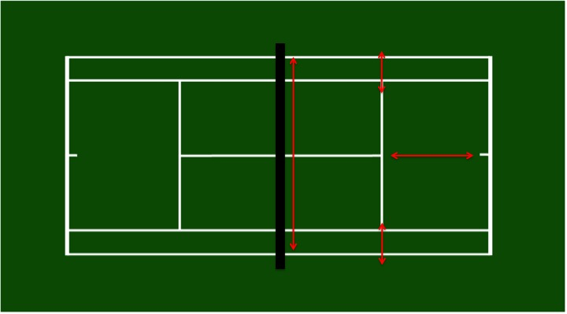

Objective: Ghosts try to tag all pac-men. Once a pac-man is tagged he leaves the gam. The game is over once all packmen have been tagged.

Speed, turns,

Balloon games:

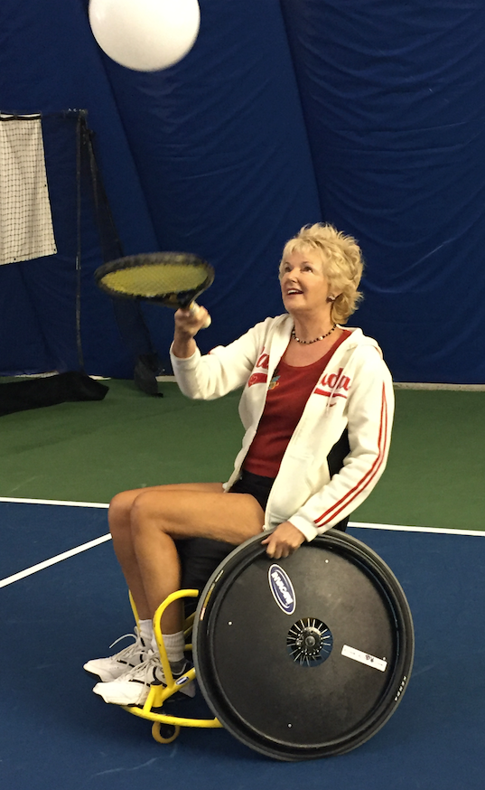

- Keep balloon in the air while standing in one spot.
Game: player to keep the balloon in the air without dropping it to the ground for longest time wins

- Keep balloon in air while moving around.

- Game: player to keep the balloon in the air without dropping it to the ground for longest time wins

- Balloon race: first to get from A to B without dropping the balloon wins

- Same games with 2 players partnering up

Advanced players use red, orange, green dot or real balls

“ Grab the Leash”

- Tag Game, Everybody on their own
- Every player has a piece of masking tape stuck to the back of their chair
- Objective: players try to “grab the leash (tape) off the other players chairs. If tape is grabbed off, player is eliminated. Last player with leash wins
- Court size: depending on # of participants court size is either full court (full gym) or half court (1/2 gym). The more participants the bigger the court.

“ Know your lines”
- Race
- Every player picks a line on the tennis court and goes to it.
- Coach calls out lines and players have to sprint to the line that has been called out.ie. (“doubles side line, center service line, baseline, net”)
- Last player to reach a line is eliminated until only one player remains

II. BEGINNER DRILLS

1. Self rallies

Balancing ball on racquet face
- Continental grip (hammer grip)
- Palm up first, then palm down
- Player balances ball on strings trying not to let it drop to the ground
Progression:
- Player balances ball and moves it clockwise and the counterclockwise around the racquet face
- Include “pit stop”: players have to get ball to land in ‘open throat” below the racquet head and then bring it back onto the strings

Self rallies without bounce (volley)
- Continental grip (hammer grip)
- Palm up
- player bounces the ball (red, orange, greed dot, real depending on skill level) off the middle of the racquet face and catches it.

Progression:
- same drill with palm down
- no catching
- alternate between palm up and palm down

Self rallies with bounce
- continental grips (hammer grip)
- Palm up
- player bounces the ball (red, orange, greed dot, real depending on skill level) off the middle of the racquet face and lets it bounce on the ground and catches it.

Progression:
- same drill with palm down
- no catching
- alternate between palm up and palm down
- put a flat marker on the ground. Ball has to bounce on the marker (create competition: first player to hit marker
- 3 times wins)

2. Cooperative rallies:

Players go through the drills above in pairs of 2. You can create games with teams competing against each other for the most rallies

3. Feeding Rallies (Coach drop or racquet feeds the ball)

- Coach and player at service line.
- Coach drop feeds balls to forehand. Player hits the ball cross court over the net towards a target on the opposite side (wheelchair, chair, box, etc.)
- Player gets a point if he/she hits the target.
- Coach makes corrections (if need be): impact point, racquet path, etc.

Progressions:
- same drill on backhand
- include movement (player has to push towards the spot where the ball has dropped and recover back to after shot)
- alternate between forehands and backhands
- competition can be held. Ie. first player/team to 3 successful target hits wins
- same drill with volleys (close to net)
- same drills with coach feeding across the net

note: targets are a great way to keep drills fun while working on technical fundamentals

“Maniac Tennis” (to finish a session)
- one team on each side of the net
- team can be made of as many players as are available
- players have to get the ball across the net. They can do so by:
  - hitting over the net
  - hitting past the net
  - hitting under the net
  - hitting around the net
  - hitting against a wall first
  - passing the ball to a teammate before hitting it over
  - a team scores a point if the ball comes to a dead stop on the other side of the court. First team to 3 or 5 points wins
  - Recommendation: players with reduced mobility skills should be positioned closer to the net. Players with more athletic abilities should try and allow the teammates to hit balls across the net.

